What is Blockchain?
Blockchain is a decentralized, distributed digital ledger that records transactions across many computers so that no single entity has full control — and once data is added, it’s extremely hard to change.
At its core, a blockchain is a chain of blocks, where each block contains data and a reference to the previous block — forming a secure, tamper-resistant chain.

What is Ledger
A ledger is a record-keeping system that tracks financial transactions or other data.

Imagine a notebook where everyone in the group writes each transaction, one after the other, in a chain of pages (blocks). Everyone has a copy, and once something is written, no one can erase or modify it without everyone knowing.

Features:
- Secure — uses cryptography and consensus
- Transparent — everyone can see the ledger
- Tamper-resistant — history can’t be changed
- No intermediaries — removes need for central authority

Why store data on many computers?
Benefit | Explanation
Decentralization | No single point of failure — no central server
Security | Data is very hard to tamper with (you’d have to hack 51%+ of all nodes!)
Transparency | All nodes can see and verify every transaction
Fault Tolerance | Even if some nodes go offline, others keep the network running

Imagine if 1,000 people are each keeping an identical diary of transactions. If one person tries to cheat and change a past entry, everyone else disagrees — and the fake version gets rejected.

What is Solidity?
Solidity is a programming language used to write smart contracts on the Ethereum blockchain (and other compatible blockchains like Polygon, Binance Smart Chain, etc.).
What is a Smart Contract?
A smart contract is a self-executing program that runs on the blockchain. It’s:
- Immutable (can’t be changed after deployment)
- Transparent (anyone can see the code)
- Trustless (no need for middlemen)

Can Blockchain Be Hacked?
Technically, yes — but it's extremely difficult.
Blockchains are not unhackable, but they’re designed to be highly secure through decentralization, cryptography, and consensus mechanisms.
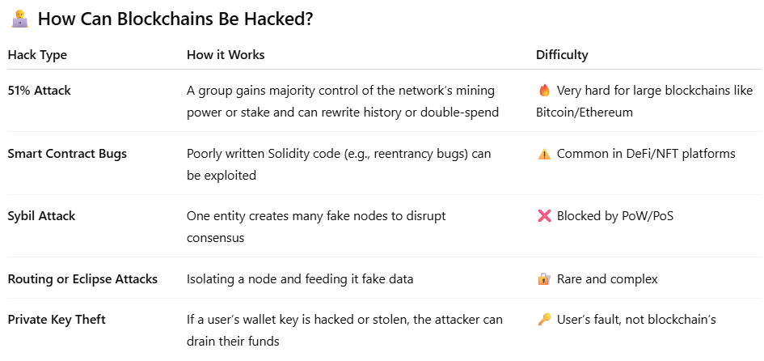

What is Ganache?
Ganache is a personal Ethereum blockchain you can run on your local computer for development and testing.
Ganache is a fast, local Ethereum blockchain used for learning, testing, and developing smart contracts safely.
Why use Ganache?
Ganache allows developers to:
- Deploy smart contracts locally (no real ETH needed)
- Test DApps quickly
- Inspect and debug transactions
- Simulate gas costs, block mining, and account balances

